**May 12 Home questions**

#1. WAP to change the value of constant integer using pointers.

Code:

#include <stdio.h>

int main()

{

    const float pi_285=3.14;

    float *ptr_285;

    int n;

    ptr_285=&pi_285;

    printf("The value of pi is %f\n",*ptr_285);

    printf("But its okay, give your own desired value to pi\n");

    scanf("%f",ptr_285);

    printf("=-=-==-=-=-=-=-=-=-==-=-=-=-=-=-\n");

    printf("The new value you have given is = %f\n",*ptr_285);

    printf("=-=-==-=-=-=-=-=-=-==-=-=-=-=-=-\n");

    n=1%10;

    printf("%d ",n);

    return 0;

}

Output:

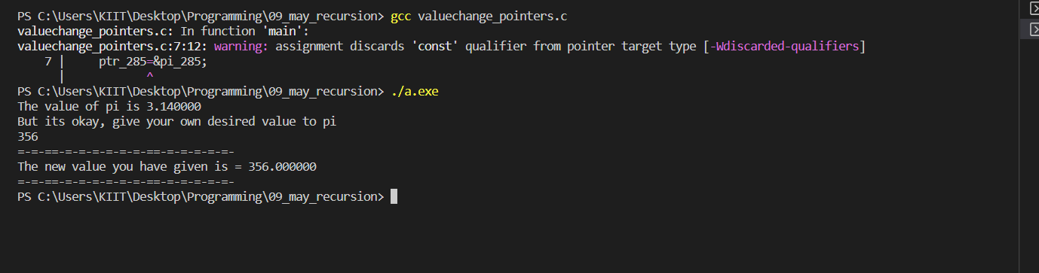

#2. WAP to count distinct number of vowels and consonants present in a string

using pointer.

Code:

#include <stdio.h>

#include <string.h>

int main()

{

    char arr_285[20], *ptr_285;

    int i,n,cCount_285,vCount_285;

    printf("Provide your string\n");

    fgets(arr_285,20,stdin);

    ptr_285=&arr_285[0];

    n=strlen(arr_285);

    while(*ptr_285!='\0')

    {

        if(*ptr_285=='U'|| *ptr_285=='O'|| *ptr_285=='I'|| *ptr_285=='E'|| *ptr_285=='A'|| *ptr_285=='u'|| *ptr_285=='o'|| *ptr_285=='i'|| *ptr_285=='e'|| *ptr_285=='a')

            vCount_285++;

        ptr_285++;

    }

    cCount_285=n-vCount_285-1;

    printf("The total number of vowels is %d\n",vCount_285);

    printf("The total number of consonants is %d\n",cCount_285);

    return 0;

}

Output:

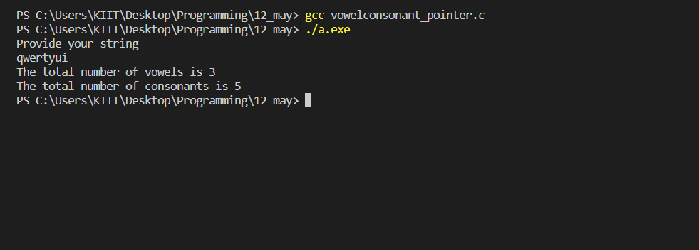

#3. WAP to print all permutations of a given string using pointers.

Code:

#include <stdio.h>

#include <string.h>

void changePosition(char *ch1, char *ch2)

    {

        char tmp;

        tmp = *ch1;

        *ch1 = *ch2;

        *ch2 = tmp;

    }

void charPerm(char *cht, int startnum_285, int endnum_285)

    {

        int i;

        if (startnum_285 == endnum_285)

            printf("%s  ", cht);

        else

        {

            for (i = startnum_285; i <= endnum_285; i++)

            {

                changePosition((cht+startnum_285), (cht+i));

                charPerm(cht, startnum_285+1, endnum_285);

                changePosition((cht+startnum_285), (cht+i));

            }

        }

    }

int main()

    {

        char str_285[4];

        printf("Input a 4 letter word: ");

        scanf("%s",str_285);

        printf("\n Permutations of given string using pointers:\n");

        int n = strlen(str_285);

        printf(" The permutations of the string are : \n");

        charPerm(str_285, 0, n-1);

        printf("\n\n");

        return 0;

    }

Output:

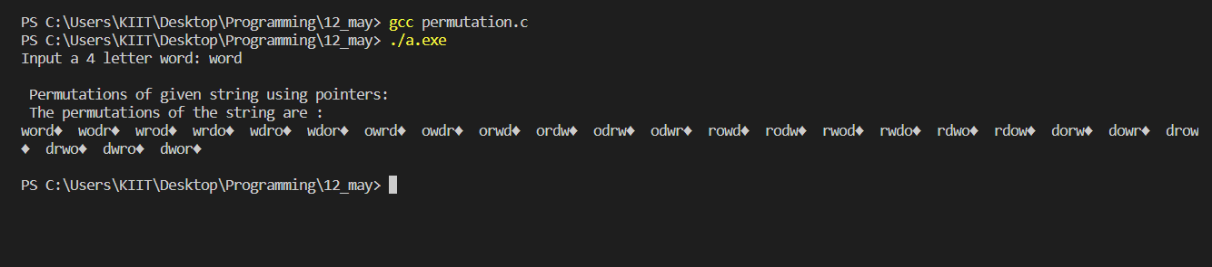

#4. WAP to swap two consecutive characters starting from left to right of a

string. (Hint: Take two pointers and increment by 2.)

Code:

#include <stdio.h>

#include <string.h>

void swap(char* ptr1_285, char* ptr2_285)

{

    char temp;

    temp = *ptr1_285;

    *ptr1_285= *ptr2_285;

    *ptr2_285= temp;

}

int main()

{

    int i,j,n;

    char *ptr1_285,*ptr2_285,string[20];

    printf("Please give a short string\n");

    gets(string);

    ptr1_285=&string[0]; ptr2_285=&string[1];

    n= strlen(string);

    for(i=0;i<n-1;i++)

    {

        swap(ptr1_285,ptr2_285);

        ptr1_285++;

        ptr2_285++;

    }

    printf("After swapping every two character from left to right\n");

    puts(string);

    return 0;

}

Output:

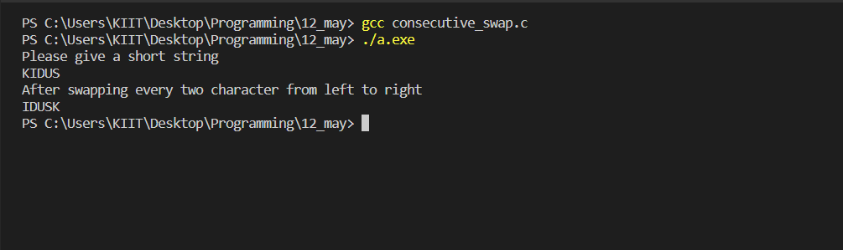

#5. WAP to find the number of times that a given word (i.e. a short string)

occurs in a sentence (i.e. a long string!).

Code:

#include <stdio.h>

#include <string.h>

int main()

{

    int i,j,count_285,n;

    char arr_285[30][30],sub_285[30];

    printf("How many words does your sentence have?\n");

    scanf("%d",&n);

    printf("Please provide a sentence\n");

    for(i=0;i<n;i++)

    {

        scanf("%s",arr_285[i]);

    }

    printf("What is the string you are looking to count?\n");

    scanf("%s",sub_285);

    for(i=0;i<n;i++)

    {

        if(strcmp(arr_285[i],sub_285)==0)

        count_285++;

    }

    printf("count=%d",count_285);

    return 0;

}

Output:

